SRM Institute of Science and Technology  College of Engineering and Technology

DEPARTMENT OF ECE

SRM Nagar, Kattankulathur – 603203, Chengalpattu District, Tamilnadu

**Academic Year: 2024-2025 (Even)**

**21ECC302T Analog and Digital Communication**

**Assignment- Answer Key**

**Year & Sem: III & VI Max. Marks: 30**

**Q1.** The signal should be sampled at a frequency 5×2=10 kHz (Sampling theorem). Each sample is then quantized to one of the eight levels. Looking at each quantized level as a message, we get

H = - (0.25 log 0.25 + 0.2 log 0.2 + 0.2 log 0.2 + 0.1 log 0.1 + 0.1 log 0.1 + 0.05 log 0.05 + 0.05 log

0.05 + 0.05 log 0.05)

**= 2.74 bits/message (3 Marks)**

As the sampling frequency is 10 kHz, the message rate = 10,000 messages/s. Hence, the rate of information is

R = rH = 10,000 × 2.74 **= 27,400 bits/s. (2 Marks)**

**Q2. (2 Marks)**

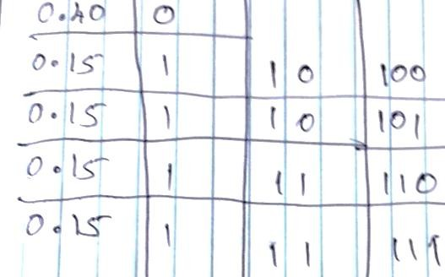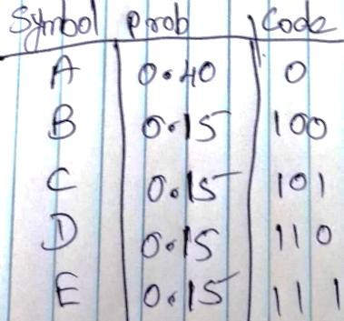

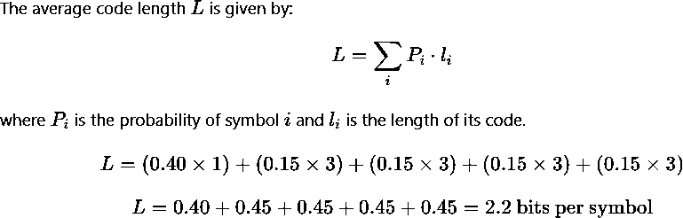**(3 Marks)**

**(3 Marks)**

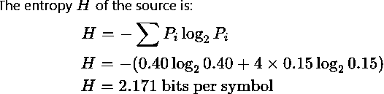

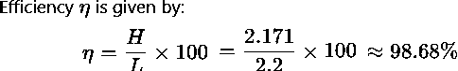**(2 Marks)**

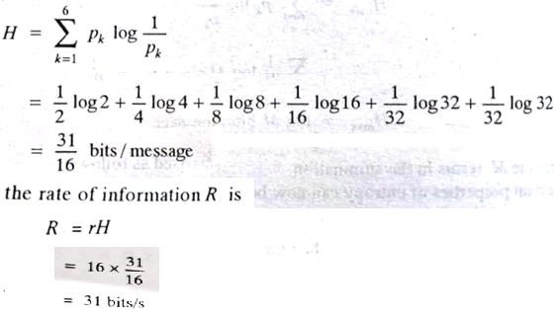**Q3.**

**(3 Marks)**

**(2 Marks)**

Q4. **(2 Marks)**

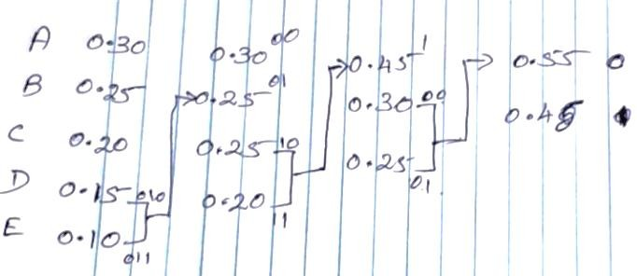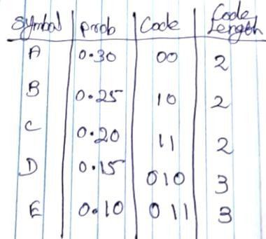

The average code length (L) is calculated by multiplying the length of each code by its probability and summing the results:

L = (0.30 * 2) + (0.25 * 2) + (0.20 * 2) + (0.15 * 3) + (0.10 * 3)

L = 0.60 + 0.50 + 0.40 + 0.45 + 0.30

L = 2.25 bits/symbol **(3 Marks)**

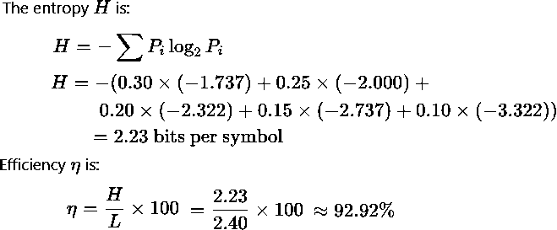**(3 Marks)**

**(2 Marks)**